App screenshots (prior to testing)
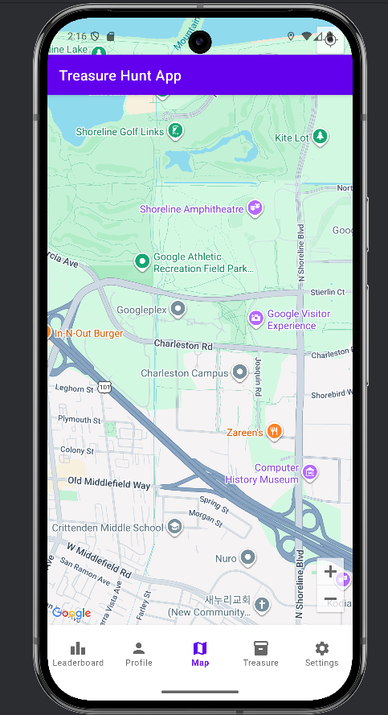
1 Map Fragment
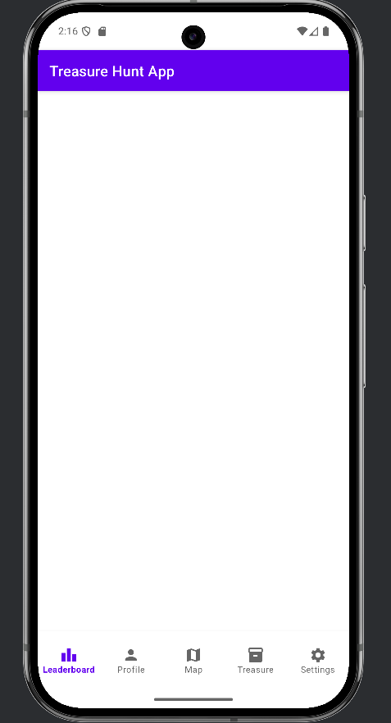
2 Leaderboard Fragment (void)
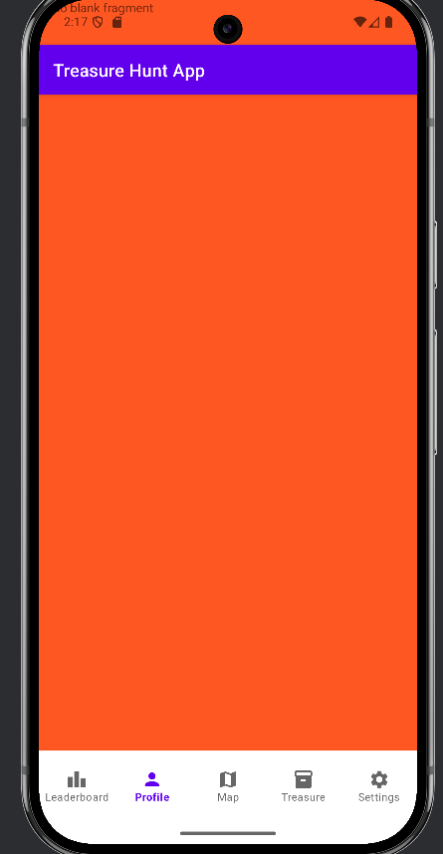
3 Profile Fragment (void)
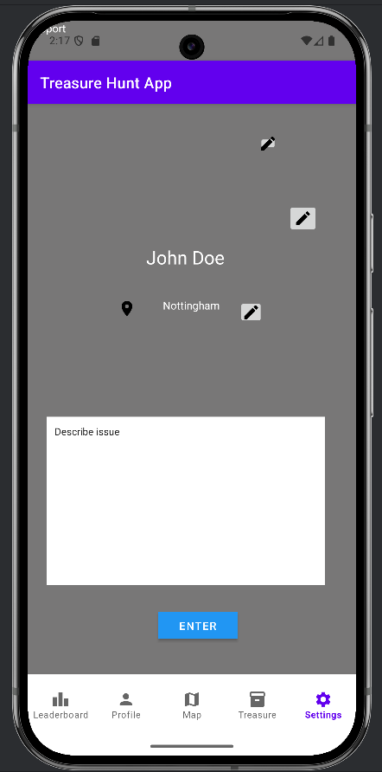
4 Support Fragment
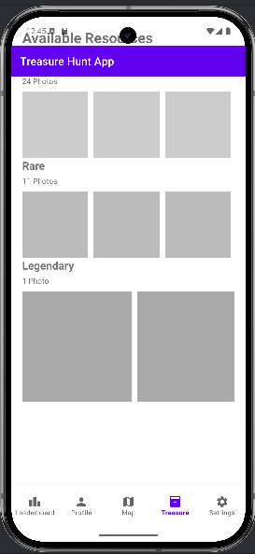
5 Treasure Fragment
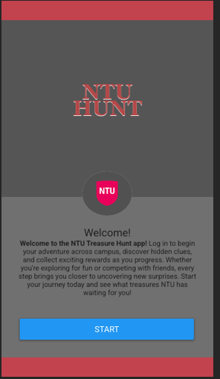
6 Main activity (Welcome Page)
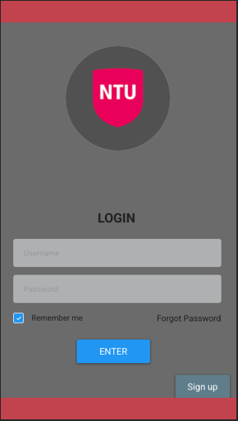
7 Login

User feedback:

Participant: Prince
• What did you expect this app to do before you tapped anything?
Answer: I expected it to be a treasure‑hunt app; this was clear and self‑explanatory from the first screen.

• How easy or difficult was it to understand how to start a treasure hunt?
Answer: It was quite difficult. A tutorial on first launch would help me understand how to begin.

• Were there any terms, icons, or screens that felt unclear or confusing?
Answer: No, everything was clear and straightforward as of now. Obviously, there is not much to go off because the app is practically empty, however the navigation and support tab look clear and understandable.

• Was it easy to find the features you needed (e.g., hints, map, progress)?
Answer: NO, the features were not even available. The only clear one to find is map.

• If you could change one thing about the app, what would it be?
Answer: I would add the ability to view other players’ statistics on the leaderboard.

Participant: Bola
• What did you expect this app to do before you tapped anything?
Answer: It was obvious that the app was related to a treasure hunt because of the “NTU Hunt” label.

• How easy or difficult was it to understand how to start a treasure hunt?
Answer: There was nothing that clearly indicated how to start. A tutorial for first‑time users is needed.

• Were there any terms, icons, or screens that felt unclear or confusing?
Answer: No, everything was straightforward but looked rushed.

• Was it easy to find the features you needed (e.g., hints, map, progress)?
Answer: Not really. A tutorial should also explain how to navigate these features.

• If you could change one thing about the app, what would it be?
Answer: Add a tutorial and include a beacon‑style mechanism to indicate when the user is near a treasure.

Participant: Jerry
• What did you expect this app to do before you tapped anything?
Answer: At first glance, the app felt like a gamified guide to exploring NTU and discovering new things around campus.

• How easy or difficult was it to understand how to start a treasure hunt?
Answer: Not easy at all. A tutorial is needed at the start to explain the app and how to navigate it.

• Were there any terms, icons, or screens that felt unclear or confusing?
Answer: No, everything was clear about the available content.

• Was it easy to find the features you needed (e.g., hints, map, progress)?
Answer: Yes, the features were easy to find, and the layout was effective, however not all features are implemented. I do not see hints or progress but as for map it is clear to navigate too.

• If you could change one thing about the app, what would it be?
Answer: I would add more customization options, a user-friending system, and a section that provides feedback.

App screenshots (post-user testing):
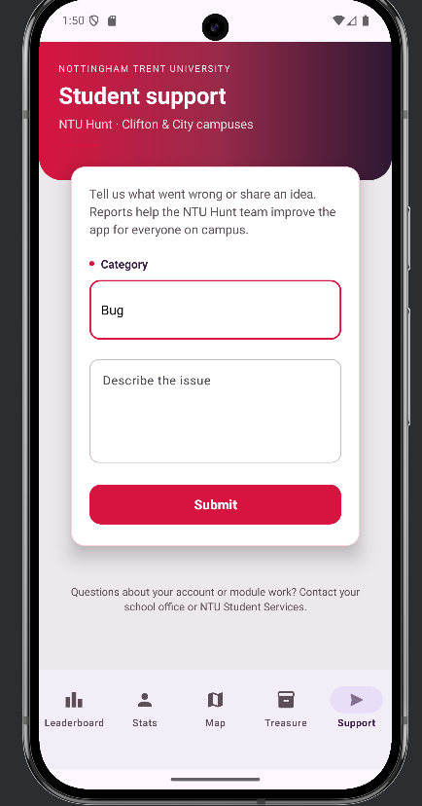
8 Support Fragment (post testing 1)
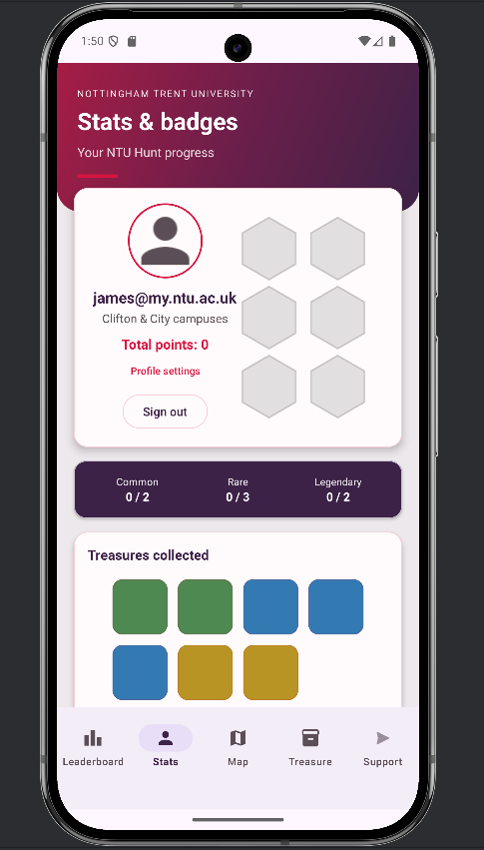
9 Profile Fragment (post testing 1)
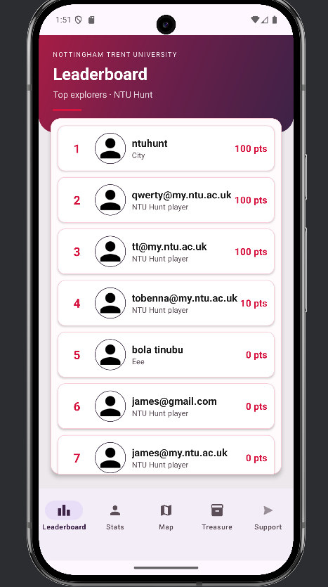
10 Leaderboard Fragment (post testing 1)
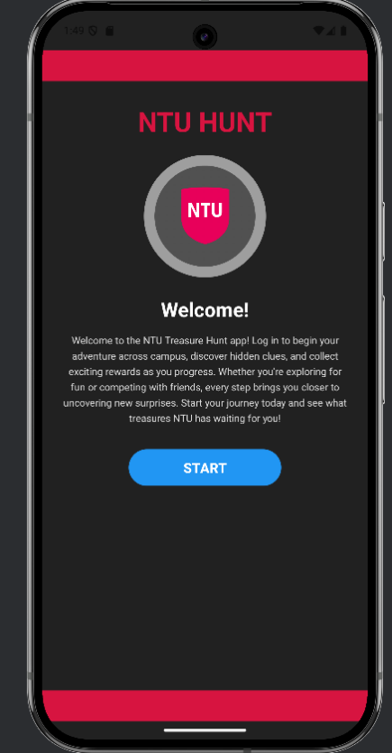
11 Main activity (post testing 1)
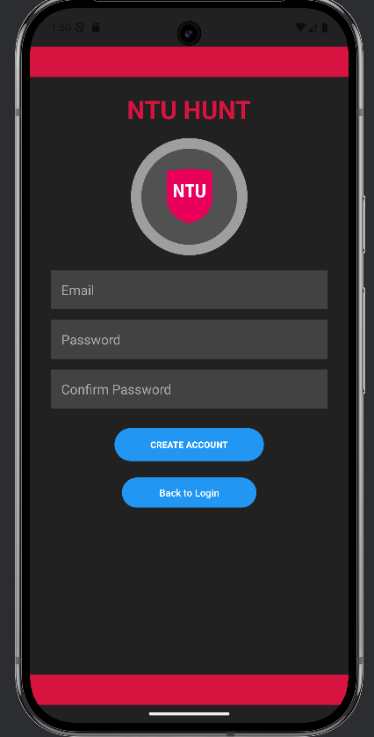
12 Signup (post testing 1)
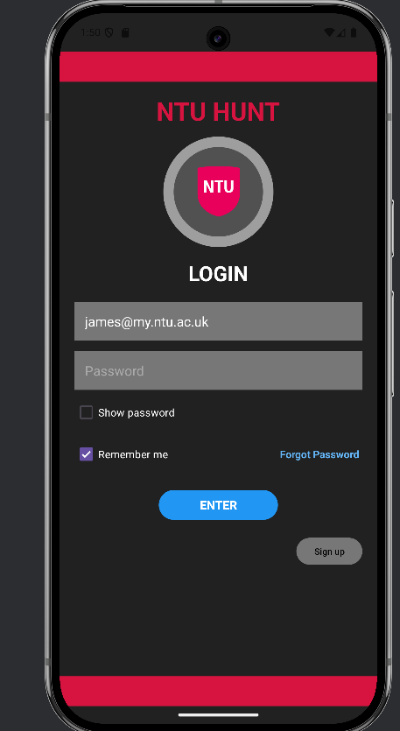
13 Login (post testing 1)
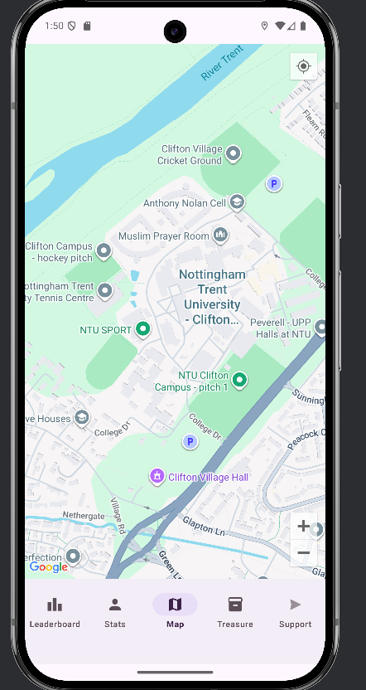
14 Map Fragment (post testing 1)
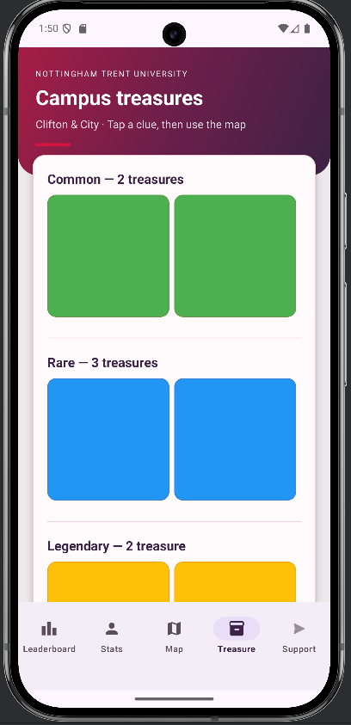
15 Treasure Fragment (post testing 1)
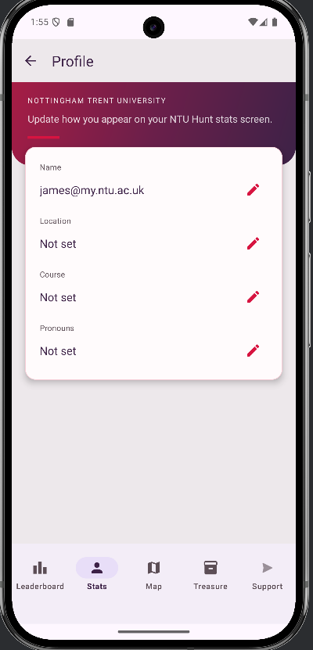
16 Profile Fragment (settings) (post testing 1)

Discussion:
Usability testing with three participants surfaced recurring themes: onboarding (how to begin a hunt), discoverability of secondary features (hints, progress, non-map tabs), proximity-based play on the map, social comparison via the leaderboard, and channels for feedback and customization. The following paragraphs relate those themes to design rationale and to concrete changes embodied in NTU Hunt.
Onboarding and how to start
Prince, Bola, and Jerry all reported difficulty understanding how to start a treasure hunt without prior explanation. This aligns with the help and documentation heuristic: first-time users benefit from task-oriented guidance now of need, not only from static labels (Nielsen and Molich, 1990). In response, the application introduces a first-launch tutorial implemented as TutorialPopup, which persists a per-account flag in SharedPreferences (keyed by Firebase UID or email via tutorialAccountKey) so each user sees the walkthrough once. The dialog is inflated from dialog_tutorial.xml. It is triggered from navigation.java after the root layout is posted, so the map shell is visible behind a dimmed overlay—supporting visibility of the current context while instructions are shown. Dialog presentations use NtuMaterialDialogs and MaterialAlertDialogBuilder, following Material Design guidance for modal surfaces and clear content hierarchy (Google LLC, n.d.).
Navigation, hints, and progress
Participants noted that only the map felt obviously available, or that hints and progress were hard to find or absent. The shell activity wires bottom navigation in navigation.java to map, treasure browsing, leaderboard, profile or stats, and support—consistent with Material Design recommendations for bottom navigation where a small set of primary destinations is always visible (Google LLC, n.d.). Hints are delivered in context: TreasureFragment opens a dialog (item_hint.xml) showing clue and hint before the user accepts the hunt (ActiveTreasureManager). Progress is surfaced on the stats screen (ProfileFragment): rarity counts, total points, badge grid, and walk distance (WalkDistanceTracker), with game state pushed to Firestore via UserGameStateFirestoreSync. Together, these address the gap between a sparse first impression and structured affordances for exploration and feedback on advancement.
Proximity and map-based discovery
Bola requested a beacon-style cue when near a treasure. The implementation in MapFragment uses the Fused Location Provider with a LocationCallback (proximityCallback) to refresh markers periodically while an active hunt exists. The treasure pin appears only when the user is within a defined radius (PIN_VISIBLE_METERS), and collection is gated by a tighter threshold (COLLECT_TAP_METERS). That pattern, proximity-gated disclosure, escalates information as spatial constraints are met and reduces clutter when the user is far from the target, which is consistent with progressive disclosure as a usability principle often discussed alongside Nielsen’s heuristics (Nielsen and Molich, 1990). Location updates are stopped when the fragment pauses (stopProximityUpdates), limiting unnecessary sensing. The design therefore addresses the intent of a “beacon” through location-triggered visibility of the target.
Leaderboard and other players’ statistics
Prince asked to view other players’ statistics from the leaderboard. LeaderboardFragment listens to the user’s collection in Firestore, sorts by score, and renders rows with LeaderboardAdapter. Tapping a row opens PublicPlayerStatsDialog, which loads that user’s document and presents name, score, avatar, and summary text in dialog_public_player.xml. Visible comparison with peers is a common motivational mechanism in gamified applications (Hamari et al., 2014). The implementation exposes only fields held in the shared user document, which supports transparency for leaderboard use while avoiding unnecessary disclosure of unrelated data.
Feedback, support, and further customization
Jerry suggested feedback and more customization. The Support destination hosts SupportFragment, with a category spinner and message field (fragment_support.xml) and submission to the Firestore collection support_reports for authenticated users, an in-app channel for structured feedback. Customization is partially addressed through SettingsFragment (profile fields and photo sync via ProfilePhotoFirestoreSync and UserProfileFirestoreSync), which also affects how the user appears on the leaderboard. A full social graph (for example user-to-user friending) is not part of the current implementation.

Reference list
Google LLC (n.d.) Material Design. Available at: https://m3.material.io/ (Accessed: 11 April 2026).
Hamari, J., Koivisto, J. and Sarsa, H. (2014) ‘Does gamification work? – a literature review of empirical studies on gamification’, in Proceedings of the 32nd Annual ACM Conference on Human Factors in Computing Systems (CHI ’14). New York: ACM, pp. 3025–3034. doi: 10.1145/2556288.2556577.
Nielsen, J. and Molich, R. (1990) ‘Heuristic evaluation of user interfaces’, in Proceedings of the SIGCHI Conference on Human Factors in Computing Systems (CHI ’90). New York: ACM, pp. 249–256. doi: 10.1145/97243.97281.

